IDEATION PHASE
Brainstorming – Idea Generation & Prioritization
Project Planning Document
Date | 5 September 2026
Student Name | Bantupalli Niharika
Project Name | Automated Network Request & Fulfillment Management System
1. Brainstorming Overview
The ideation activity explores how a centralized ServiceNow-based application can organize network-related service requests such as Wi-Fi, LAN, VPN and other connectivity services. The proposed system aims to make request submission structured, route work to the appropriate team and provide visibility into request progress. The ideas below cover request intake, data capture, workflow automation, task fulfillment, communication and reporting.
2. Objective of the Ideation Activity
The objective is to identify the main features required for a manageable network request process, group related ideas into functional areas and decide which capabilities should receive priority. This helps define a practical project scope and provides a clear starting point for designing the application.
3. Problem Identification
Network-related requests may arrive through different communication channels and may not always contain the same information. This can make it harder to track request details, identify the responsible team, monitor approvals and communicate progress. A centralized request process can help organize these activities in one place.
4. Proposed Solution
The proposed solution is a ServiceNow application that uses a Service Catalog item to collect network requests through a guided form. Catalog variables and UI policies can support structured and dynamic data capture. Approval automation, task creation and assignment can organize fulfillment activities, while status tracking and notifications can improve request visibility. Reports and dashboards can support later review of request activity.
5. Idea Generation and Prioritization
Ideas were generated across the main stages of the request lifecycle: request submission, information capture, approval, task fulfillment, communication and monitoring. Each idea was assigned a functional group and a priority. High priority is used for capabilities central to the core request-to-fulfillment process; Medium priority is used for supporting capabilities that add communication or analytical value.
Idea | Functional Group | Priority | Reason for Priority
Service Catalog | User Request Management | High | Provides a central entry point for network service requests.
Network Request Catalog Item | User Request Management | High | Captures network request details in a consistent format.
Custom Network Database Table | Data Management | High | Stores project-specific network request information in a structured way.
Network Task Table | Task Management | High | Supports tracking and handling of fulfillment tasks.
Catalog Variables | Structured Data Capture | High | Collects the information required to process each request.
Catalog UI Policies | User Experience | High | Can show, hide or make fields mandatory based on request selections.
Approval Automation | Workflow Automation | High | Routes requests through the required approval process.
Automated Network Task Creation | Workflow Automation | High | Creates fulfillment work after the relevant request steps.
Assignment to Network Fulfillment Team | Task Management | High | Directs tasks to the team responsible for handling them.
Email Notifications | Communication | Medium | Keeps users and relevant teams informed about request progress.
Request Status Tracking | Monitoring | High | Allows users and support teams to follow request progress.
Reports and Dashboards | Analytics | Medium | Helps review request volumes and operational trends.

6. Prioritization Criteria
The following practical considerations were used to explain the priority levels. These are planning criteria for this brainstorm, not measured project results.
• Core process importance: Whether the idea is needed to submit, process or fulfill a network request.
• Operational value: Whether it improves ownership, consistency or visibility of request handling.
• Supporting value: Whether it mainly adds communication, monitoring or analysis after the core workflow is in place.
7. Feasibility and Expected Benefits
The proposed features are aligned with common ServiceNow application capabilities, including Service Catalog, catalog variables, UI policies, tables, approvals, tasks, notifications and reporting. Their exact implementation will depend on the available ServiceNow instance, permissions and project configuration.
Expected benefits include:
• A consistent way for users to submit network-related requests.
• Better organization of request information and fulfillment tasks.
• Clearer routing of work to the responsible team.
• Improved visibility of approvals and request status.
• A foundation for reviewing request activity through reports and dashboards.
8. Final Selected Idea
Based on the brainstormed list, the selected direction is to develop an Automated Network Request & Fulfillment Management System on ServiceNow. The core scope will focus on catalog-based request submission, structured data capture, approval handling, automated task creation, team assignment and status tracking. Notifications and reporting will act as supporting features.
9. Priority Summary
A total of 12 ideas were identified: 10 High-priority ideas and 2 Medium-priority ideas. The distribution is shown below.
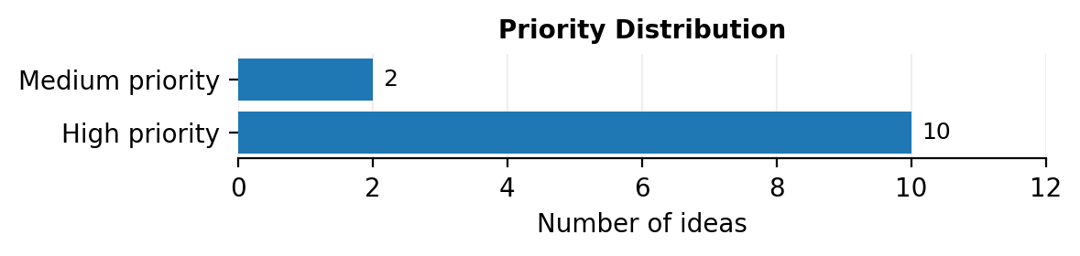
Figure 1. Distribution of the brainstormed ideas by assigned priority.
10. Conclusion
The brainstorming and prioritization activity has identified the main capabilities needed for the proposed network request management application. Prioritizing request intake, structured data capture, approvals, task creation, assignment and status tracking establishes a clear core scope. Communication and reporting features can complement the workflow and support a more organized service request process.

